Lab 1 Write Up

Alex Horton
SWE 2410 121: Design and Cloud Patterns
Dr. Adela Velez
January 22, 2026

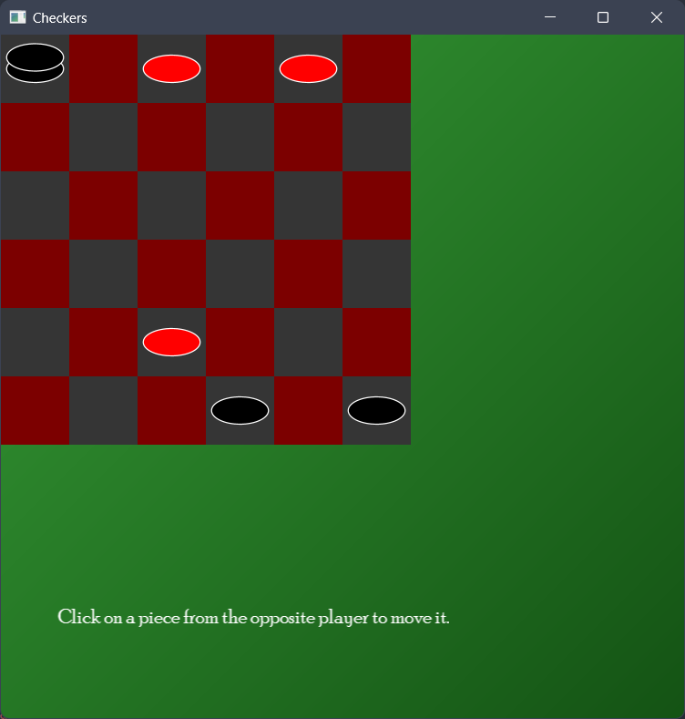
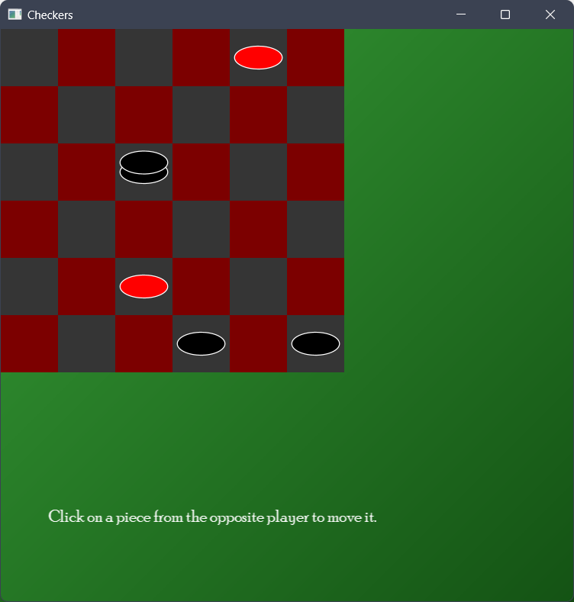

Reflection:
Question 1: How making your original code more modular can make modifications easier in the future.
Question 2: How the piece class was structured made modifying the methods easier but it was difficult to find some of the methods because similar functions weren’t grouped together.
Question 3: I would maybe move some methods around but other than that not much.

